Use-Case Realization Report (Analysis)
System Start-Up & Close-Down

Issue 3.0
Revision History
Date | Issue | Description | Author
18 July 2000 | 1.0 | First Issue | Howard Russon
2 August 2001 | 2.0 | Revised for MTech Unit 3 in 2001 | Howard Russon
20 July 2004 | 3.0 | Revised for MTech Unit 3 in 2004 | Howard Russon

Table of Contents
1. Brief Description 4
2. Flow of Events 4
2.1 Standard Flow 4
2.1.1 Initial Running of the Application 4
2.1.2 System Start-Up 5
2.1.3 System Close-Down 5
2.2 Exceptions 5
3. Interaction Diagrams 6
3.1 Collaboration Diagram: Application Start-Up 6
3.2 Collaboration Diagram: System Start-Up 6
3.3 Collaboration Diagram: System Close-Down 7
4. Participating Objects 7
5. Class Diagrams 9
5.1 Class Diagram: System Start-Up and Close-Down 9
6. Derived Requirements 10

Use-Case Realization Report
System Start-Up & Close-Down

Brief Description
This use case enables the Controller to start-up and close-down the computer simulation of the vending machine. This involves displaying a Simulation Control Panel (when the application is launched). Using the panel, the Controller will be able to start-up the simulation or exit from the application.

Flow of Events
The standard flow of events for this use case and any exceptions are described in the following subsections. The events are described in terms of Actors and Analysis Objects.

Standard Flow
This use case covers three main events: the initial running of the application, and the starting-up and closing-down of the system. The standard flow for these events are described below.

Initial Running of the Application
The initial running of the application is shown in section 3.1. The flow of events is as follows:

- When the application opens, the first operation to be performed is the StartUp operation of the Main Controller. This operation will create all the control objects and the entity objects necessary for simulation of the vending machine:
- The control objects created are: Simulation Controller, Maintenance Controller, Transaction Controller, Coin Receiver, Dispense Controller, Change Giver, Store Controller, Transfer Cash Controller and the Access Manager.
- The entity objects created are: Door, Drinks Store and the Cash Store.
- The configuration information will then be read-in from the input file by using operation Load of Configuration Information.
- The Cash Store will then be initialized to values read from an input file as follows:
- Operation ReadCash of Configuration Information will be used to read the attributes of a Coin denomination.
- Operation InitialiseCoin of Cash Store will then be used to store the attributes in a Coin. To do this operations SetName, SetValue, SetWeight and SetQuantity (all of Coin) will be used.
- Steps (a) and (b) will be repeated until all denominations have been read from the file.
- The Drinks Store will then be initialized to values read from an input file as follows:
- Operation ReadDrinks of Configuration Information will be used to read the attributes of a Drinks Brand.
- Operation InitialiseDrink of Drinks Store will then be used to store the attributes in a Drinks Brand. To do this:
  - Operation GetItem of Drinks Store is used to find the Drinks Store Item that corresponds to the brand.
  - Operation SetQuantity of Drinks Store Item is then used to set the initial stock of the brand, and operation GetBrand of Drinks Store Item is used to find the Drinks Brand.
  - Operations SetName and SetPrice (both of Drinks Brand) are then used to set the name and price of the brand.
- Steps (a) and (b) will be repeated until all brands have been read from the file.
- The Simulation Controller will then create and display the Simulator Control Panel. The Simulation Controller will use operation Display of the Simulator Control Panel to accomplish this task. The Begin Simulation Button on this panel will be active (ie selectable). The other buttons will be deactivated (ie greyed).

System Start-Up
The start-up of the system is shown in section 3.2. The flow of events is as follows:

- To start the machine, the Controller presses the Begin Simulation Button on the Simulator Control Panel. This action triggers the Begin operation of Begin Simulation Button which uses the Start operation of the Simulation Controller.
- The Start operation of the Simulation Controller instructs the Simulator Control Panel to activate the End Simulation Button (using operation Activate of the button), Activate Maintainer Panel Button (using operation Activate of the button), Activate Customer Panel Button (using operation Activate of the button), Activate Machinery Simulator Button (using operation Activate of the button), and deactivate the Begin Simulation Button (using operation Deactivate of the button).

System Close-Down
The close-down of the system is shown in section 3.3. The flow of events is as follows:

- To exit from the system, the Controller presses End Simulation Button on the Simulator Control Panel. This action triggers the End operation of the End Simulation Button that uses the Stop operation (of the Simulation Controller) to inform the Simulation Controller of the exit request. This operation in turn sends a message to inform the Main Controller by using operation CloseDown (of Main Controller).
- The Main Controller then stores the current state of the Cash Store in the input file as follows:
- Operation GetCoinData is used to retrieve the attributes of a Coin of a denomination. To do this operations GetName, GetWeight, GetValue and GetQuantity (all of Coin) are used.
- The data is then written to the file by using operation WriteCash of File Interface.
- Steps (a) and (b) will be repeated until all denominations have been written to the file.
- The Main Controller then stores the current state of the Drinks Store in the input file as follows:
- Operation GetDrinkData is used to retrieve the attributes of a Drinks Brand. To do this:
  - Operation GetItem of Drinks Store is used to find the Drinks Store Item that corresponds to a brand.
  - Operation GetQuantity of Drinks Store Item is then used to get the current stock of the brand, and operation GetBrand of Drinks Store Item is used to find the Drinks Brand.
  - Operations GetName and GetPrice (both of Drinks Brand) are then used to get the name and current price of the brand.
- The data is then stored in the Configuration Information object by using operation WriteDrinks (of Configuration Information).
- Steps (a) and (b) will be repeated until all brands have been stored in the Configuration Information object.
- The stored data is then written back to the input file by using operation Store (of Configuration Information).
- The Main Controller will then send messages to all control objects (by using their respective CloseDown operations) to instruct them to terminate their constituent objects. The control objects will also be terminated as part of these operation calls.
- The Main Controller will then remove all panels from the display using their respective CloseDown operations. The application will then finally terminate.

Exceptions
The following exceptions have been identified:
- Input File Not Found (1). If the input file cannot be found/read during operations ReadCash and ReadDrinks (of File Interface), then all the data items will be assumed to be zero.
- Input File Not Found (2). If the input file cannot be found/written to during operations WriteCash and WriteDrinks (of File Interface), then a new file will be created.

Interaction Diagrams

Collaboration Diagram: Application Start-Up
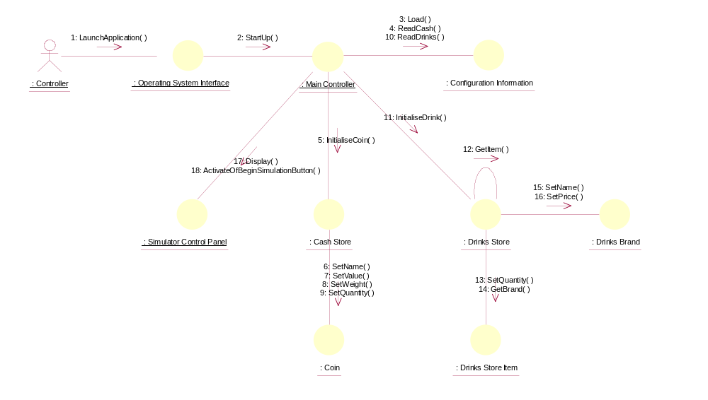

Collaboration Diagram: System Start-Up
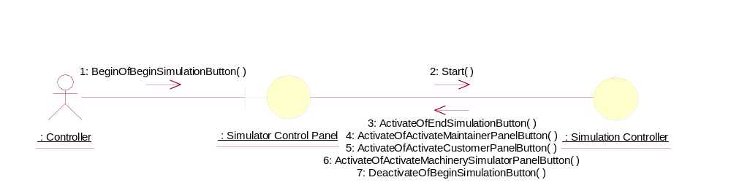

Collaboration Diagram: System Close-Down
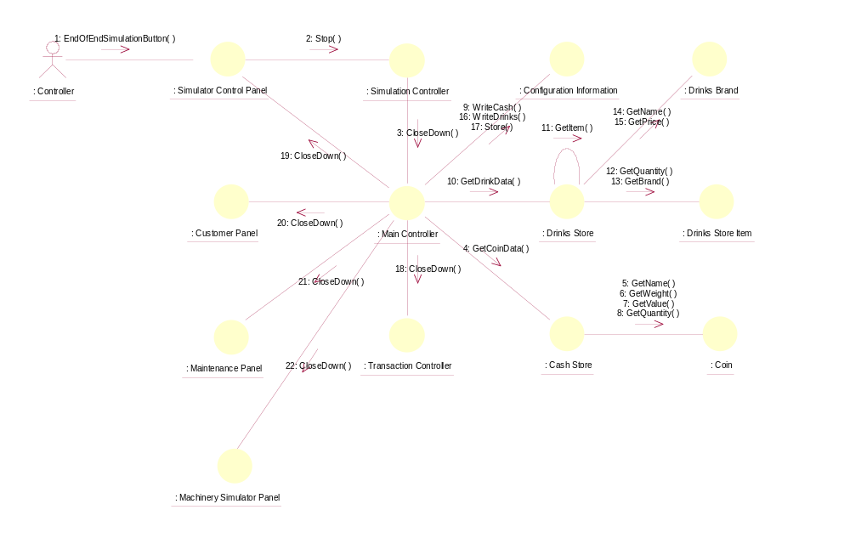

Participating Objects
: Cash Store
This object represents the store of cash in the vending machine.
: Coin
This object stores the weight and value of each type of Coin, and hence enables the machine to recognise each Coin entered.
: Configuration Information
This entity object is used to store the system configuration information.
: Controller
This actor represents the controller of the VMCS simulation. Hence it is only present in the simulated system (ie: this project) and would not be an actor of the target implementation. In particular, it performs several of the physical activities (ie: those that can not be provided by software) that are undertaken by the Maintainer in the target implementation, which include maintaining drink stocks and cash stocks inside the vending machine.
: Customer Panel
This panel simulates the vending machine's customer interface panel. It will enable the user (the Customer) to:
1 insert coins;
2 select brands;
3 terminate transaction.
It will also provide the following display functions:
1 display total money inserted;
2 indicate coin not valid;
3 indicate no change available;
4 display the value of the change to be collected;
5 display an icon representing the dispensed drink.
: Drinks Brand
This entity object stores the name of the drink brand and it's price. There can be as many drink brands as we desire, for a particular configuration.
: Drinks Store
The object is storage, in the vending machine's memory, for the total number of cans of each Drinks Brand held by the vending machine.
: Drinks Store Item
This represents a column of drinks in the vending machine. It can store a drink of any particular brand type.There can be as many drink store items as we desire in the vending machine. This number will be a configurable item for the vending machine.
: Machinery Simulator Panel
This panel simulates the physical actions of the maintainer. It enables the user to:
1 display and enter new values for the number of cans of each Drinks Brand held by the Drinks Store;
2 display and enter new values for the number of Coins of each denomination held by the Cash Store;
3 display whether the vending machine Door is unlocked, and enable it to be locked.
: Main Controller
This object is the main controller of the vending machine. It coordinates the main operations of the VMCS.
: Maintenance Panel
This panel simulates the vending machines maintainer control panel. It will enable the user (the Maintainer) to:
1 log-on using a password;
2 display number of Coins of each denomination in the Cash Store;
3 display total value of cash in the system;
4 display number cans of each Drinks Brand held in the Drinks Store;
5 change the price of any Drinks Brand;
6 collect all cash held in system;
7 formally exit from the panel.
: Operating System Interface
This object represents the operating system user interface at which the VMCS application can be launched.
: Simulation Controller
This control object is used to set up the 3 panels (Customer Panel, Maintenance Panel and the Machinery Simulator Panel) of the vending machine.
: Simulator Control Panel
This panel is displayed when the system is started up. It enables the user (the Controller) to :
1 start (switch on);
2 stop (switch off);
3 activate the customer panel;
4 activiate the maintenance panel;
5 activate the machinery simulator panel.
: Transaction Controller
This control object coordinates the customer transactions for selection of a drink brand, coin input, storage of coins and termination requests for ongoing transactions.

Class Diagrams

Class Diagram: System Start-Up and Close-Down
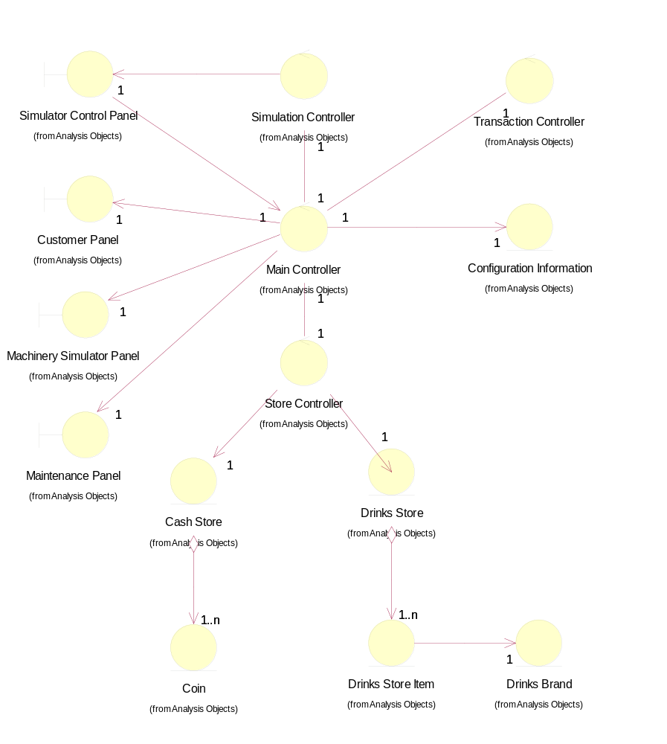

Derived Requirements
The Simulator Control Panel should have the format specified in figure 2 of "User Requirements Specification for Vending Machine Control System (VMCS) Computer Simulation", reference ISS/VMCS/TR.1/1.

